**AKS Networking:**

In AKS, you can deploy a cluster that uses one of the following two network models:

**Kubenet networking** - The network resources are typically created and configured as the AKS cluster is deployed. With kubenet, only the nodes receive an IP address in the virtual network subnet. Pods can't communicate directly with each other. Instead, User Defined Routing (UDR) and IP forwarding is used for connectivity between pods across nodes. By default, UDRs and IP forwarding configuration is created and maintained by the AKS service, but you have to the option to bring your own route table for custom route management. You could also deploy pods behind a service that receives an assigned IP address and load balances traffic for the application

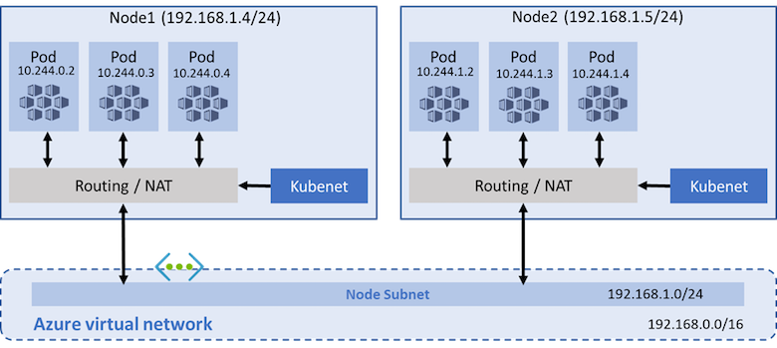

**Azure Container Networking Interface (CNI) networking** - The AKS cluster is connected to existing virtual network resources and configurations. With Azure CNI, every pod gets an IP address from the subnet and can be accessed directly. These IP addresses must be unique across your network space, and must be planned in advance. Each node has a configuration parameter for the maximum number of pods that it supports. The equivalent number of IP addresses per node are then reserved up front for that node. This approach requires more planning, as can otherwise lead to IP address exhaustion or the need to rebuild clusters in a larger subnet as your application demands grow.

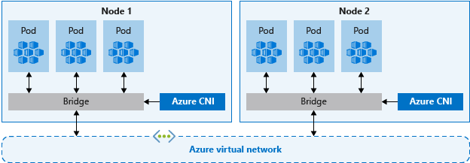

**SQL SERVER Pod with PVC**

